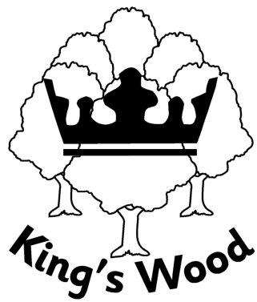
King’s Wood School Remote Learning Policy

At King's Wood there may be times when it is necessary to set learning remotely.
Remote learning because of school closure (2 - 5 days)

- No work will be set on day 1 to ensure that teachers have the time needed to plan for remote learning which, necessarily, will be different from the work that they had planned to teach in person.

- Work should be posted either the evening before, or by 8.40am in the morning. This must start by the beginning of day 2 of the absence.

- Literacy, reading, phonics and maths are to be set every day (depending on the key stage); other subjects such as science, History/Geography, RE, PSHE, MFL and Art should be set as per the timetable as far as is practicable. The work should be of a suitable level of challenge for the class, with differentiation for pupils with SEND. The EYFS team have developed a range of strategies and activities for remote learning which they will use to support progress against the EYFS curriculum.

- Teachers should, where possible, source online teaching materials, particularly videos which go through the learning steps (e.g. BBC Bitesize; Oak National Academy, MyMaths) and should signpost the child to a specific video / lesson and provide the URL. This may not be required for all subjects, but where explanation will be needed, it is important that children have access to such resources.

- The child should be encouraged to upload their work on GSuite so that their teacher can see it and give feedback. Quality feedback should be offered through GSuite.

Remote learning because of school closure (exceeding 5 days)
In addition to the above:
- Teachers will offer a blend of live teaching via Google Classroom in the mornings and more independent activities for pupils to work on at home in the afternoons. We recognise that there are sensitivities about setting up video links from home, and there may be practicalities (e.g. young children at home) which could make this difficult. However, experience has shown us that live teaching for the first part of the day is generally preferred and is more effective.

- If the child cannot access GSuite because they lack the technology at home, school will consider the loan of a laptop and – if necessary – a dongle.

- If the child is not engaging with the work, the class teacher should contact the parent to find out what the issue is and seek relevant support.

Remote learning in other circumstances
- Remote learning may occasionally be offered in other circumstances and this will be decided on a case-by-case basis if the child cannot attend school as a result of a health-related matter or social care intervention. If remote learning is offered in these circumstances, it will be through posting work on Google Classroom; there will not be any element of remote live teaching.
- Under no circumstances will we offer remote learning for pupils who miss school to go on holiday as it is our expectation that holidays are not taken during term time.

Reviewed: 18th November 2025

