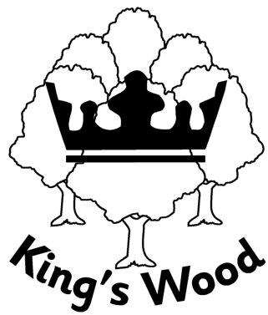
King’s Wood School and Nursery
Report on Public Sector Equality Duty
Under the Equality Act 2010
King’s Wood School and Nursery is situated within the culturally diverse area of Totteridge, High Wycombe. There are a significant number of pupils who live in this ward, and attend our school, who live in households which would be categorised as disadvantaged.
Equality Statement
King’s Wood welcomes its duties under the Equality Act 2010. We are committed to advancing equality of opportunity for all and tackling and eliminating discrimination. We seek to promote harmonious relationships in all areas of school life and positive relationships with all stakeholders and the wider community.
We recognise the need to provide an environment where everyone is valued and mutual respect is fostered. We provide opportunities for all pupils and members of staff to develop their full potential, and have due regard for the protected characteristics under the Equality Act 2010:
- Sex
- Pregnancy or maternity
- Race
- Religion or belief
- Disability
- Gender reassignment
- Sexual orientation
- Age
- Being married or in a civil partnership
We have appointed an equality governor, who is appropriately trained and qualified. We are compliant with equality legislation and we are aware of our duty to have ‘due regard’ to equality implications in all the work that we do.
We publish relevant policies on our website, e.g. Anti- Bullying
Our equality objectives for 2024-2028 are:
- To raise standards overall and narrow attainment gaps for under-performing groups
- To celebrate a range of cultures through our ethos, curriculum and school events
- To maintain zero tolerance to any discriminatory behaviour, including sexual harassment, as part of our behaviour policy and analyse behaviour incidents and bullying for any trends and address these appropriately
- To promote good relationships between all members of the school community
- To ensure the curriculum and our policies promote equality in all areas

How we meet these objectives:
- All groups of pupils are tracked and monitored to identify groups that are underperforming and appropriate strategies are put in place to close these gaps.
- A bespoke curriculum, designed by the school, celebrates cultural diversity and ensures all protected groups are represented within it.
- Assemblies, RE and PSHE teach about healthy relationships, British Values and cultural respect.
- Our behaviour policy ensures staff are vigilant and follow a consistent approach to any discriminatory incidents. These are logged and tracked on CPOMs to ensure any trends are identified quickly.
- Governors review data relating to bullying and discriminatory incidents termly and challenge the school to ensure the systems in place to address these are robust.
- Our family liaison manager supports positive relationships across our community of parents and we welcome a range of community groups into school.

Agreed: 22nd September 2026

