SEND Reading Data – Spring 2 2025-Spring 2 2026

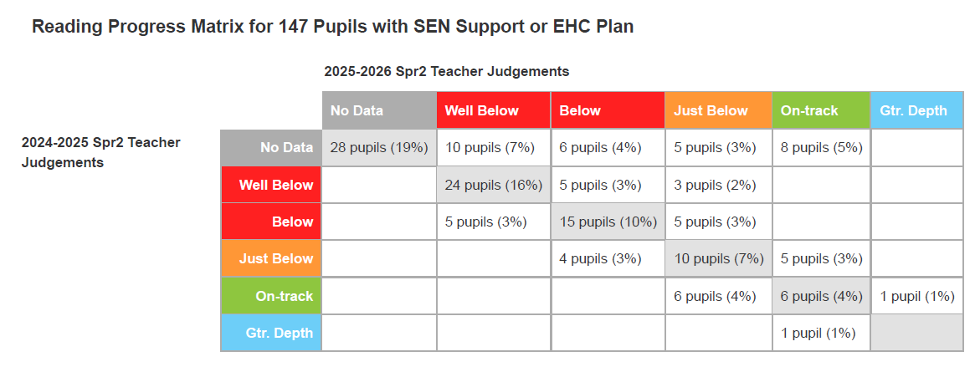

Our latest reading data for pupils with SEND demonstrates a positive upward trend in attainment over the past year. Most notably, the matrix reveals significant "upward mobility," with a high proportion of learners moving from 'Well Below' into the 'Below' and 'Just Below' categories, while others have successfully transitioned to 'On-track' or 'Greater Depth.' This progress highlights the impact of our targeted literacy interventions and the resilience of our students in overcoming barriers to learning. By focusing on individualized "small steps" of growth, we continue to ensure that every child—regardless of their starting point—is supported to become a confident and capable reader.

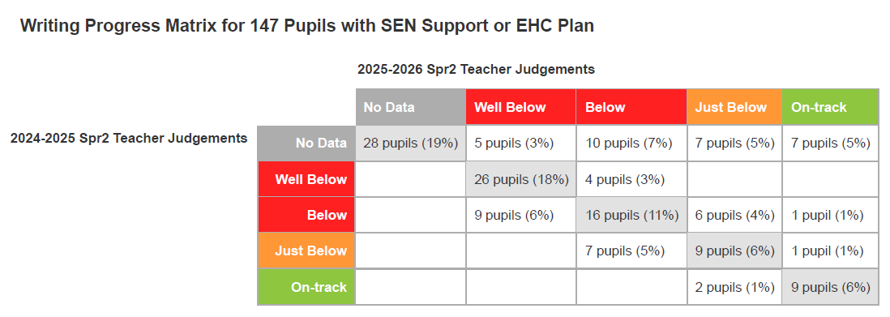
Our latest writing data for pupils with SEND showcases a journey of steady progress and successful transition of pupils towards the appropriate curriculum for their year group. The matrix highlights significant growth, particularly for those moving from 'Well Below' and 'Below' into higher attainment bands, alongside a strong cohort of new pupils who have already begun to secure positive baselines. This upward movement reflects the impact of our specialized writing support and adaptive teaching strategies, ensuring that every pupil makes meaningful steps forward from their individual starting points to become confident, expressive writers.

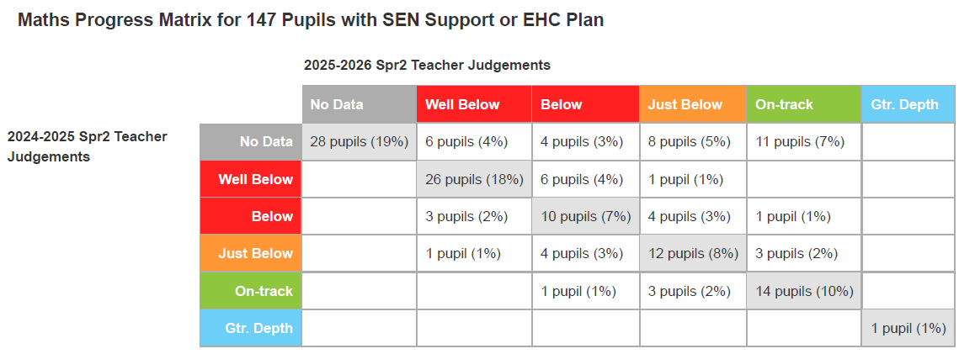
Our latest progress data for Maths highlights a strong commitment to closing attainment gaps for our pupils with SEND. The matrix shows a significant number of learners moving out of the ‘Well Below’ and ‘Below’ categories into higher bands, alongside a high level of stability for those already working at 'On-track' or 'Greater Depth.' This success is underpinned by our focus on concrete-pictorial-abstract (CPA) approaches and specialized numeracy interventions. By tailoring our support to the unique starting points of each child, we ensure they develop the mathematical fluency and confidence needed to access the appropriate curriculum for their year group.

